Question:

Over all real numbers, find the minimum value of a positive real number, y such that

y = $\sqrt{{\left(x+6\right)}^{2} + 25} + \sqrt{{\left(x-6\right)}^{2}+121}$

Answer:

Plotting the graph of y, yields the below

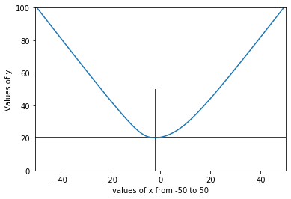

From the graph, the minimum value of y is 20.000009, approximately 20.

So, to calculate the value of x at y minimum, we can equate the y=20

Y = $\sqrt{{\left(x+6\right)}^{2} + 25} + \sqrt{{\left(x-6\right)}^{2}+121}$ = 20

$\sqrt{{\left(x-6\right)}^{2} + 121}$ = 20 - $\sqrt{{\left(x+6\right)}^{2} + 25}$

Squaring both sides

${\left(\sqrt{{\left(x-6\right)}^{2} + 121}\right)}^{2}$ = $\left(20- \sqrt{{\left(x+6\right)}^{2} + 25}\right)^2$

${\left(x-6\right)}^{2}+121$ = $400-40\sqrt{{\left(x+6\right)}^{2} + 25}+{\left(x+6\right)}^{2}+25$

${\left(x-6\right)}^{2}-{\left(x+6\right)}^{2}+121$ = $400+25-40\sqrt{{\left(x+6\right)}^{2} + 25}$

$x^{2}-12x+36-x^{2}-12x-36$ = $425-121-40\sqrt{{\left(x+6\right)}^{2} + 25}$

$-24x$ = $304-40\sqrt{{\left(x+6\right)}^{2} + 25}$

Dividing both sides by 8,

$-3x$ = $38-5\sqrt{{\left(x+6\right)}^{2} + 25}$

$5\sqrt{{\left(x+6\right)}^{2} + 25}$ = $38+3x$

Squaring both sides,

${\left(5\sqrt{{\left(x+6\right)}^{2} + 25}\right)}^{2}$ = ${\left(38+3x\right)}^{2}$

${25(x}^{2}+12x+61)$ = ${9x}^{2}+ 228x+144$ 4

${25x}^{2}+300x+1525$ = ${9x}^{2}+ 228x+144$ 4

${25x}^{2}-{9x}^{2}+300x- 228x+1525-1444$ = 0

$16x^{2}+72x+81$ = 0

Using the quadratic formula,

$$x=\frac{-b±\sqrt{b^{2}-4ac} }{2a}$$

Where a=16, b =72, c= 81

$$x=\frac{-72±\sqrt{{72}^{2}-4(16)(81)} }{2*16 }$$

$$x=\frac{-72}{\begin{aligned}32 \\ \end{aligned}}$$

$$x=\frac{-9}{4} or-2.25$$